FORMS - Onsubmit

Design a web page using form onsubmit as shown in the screenshot.

**Hints :** The submit event triggers when the form is submitted, it is usually used to validate the form before sending it to the server or to abort the submission and process it in JavaScript.

This action leads to submit event on the form. The handler can check the data, and if there are errors, show them and call event.preventDefault(), then the form won’t be sent to the server.

Sample screenshot 1 :  
  
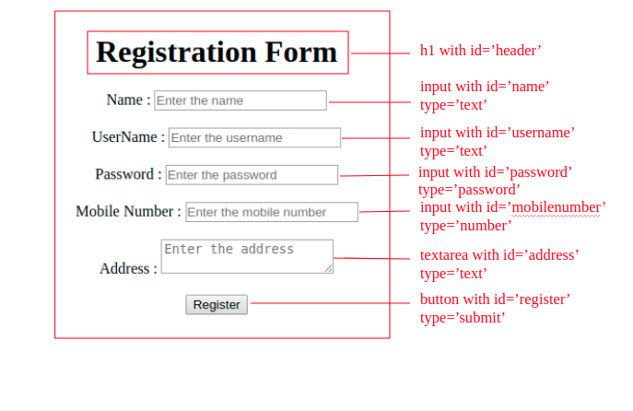  
  
Sample screenshot 2 :  
  
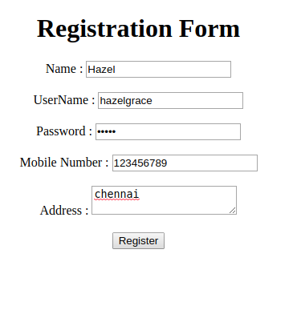  
  
Sample screenshot 3 :  
  
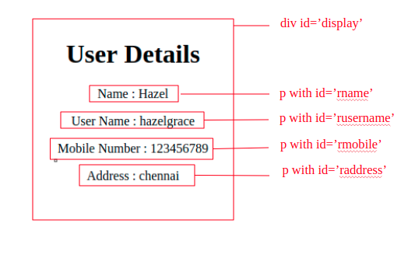  
  
Constraints :  
  
When the register button is clicked the onsubmit method should be triggered and the function should get the input   
Display the entered details.  
The form should have an onsubmit method of displayDetails() to display the entered values.